# TRUMPET THEORY TEST: NOTATION

100

**NAME: ___________ Class: ____**

**KNOWLEDGE** 25%

**Complete the following sentences:**

(8) The staff is made up of ________________________and __________________________

(8) The lines and spaces are numbered from ________________using ___________________

(8) The musical alphabet is: ____________________________________________________

**THINKING** 25%



space note over each letter name.

**APPLICATION**  25%

**COMMUNICATION**  25%

Draw the note on the staff according to the fingering. Draw the fingering according to the note on the staff.

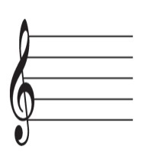      

O

#O

bO

bO

       